1st JAPAN -TAIWAN workshop on

MATERIALS DESIGN AND JOINING
May 23 – 24, 2013, Osaka, Japan

Organized by Joining and Welding Research Institute, Osaka University,
Department of Materials Science & Engineering, National Taiwan University

An agreement of academic exchange between The Department of Materials Science and Engineering, National Taiwan University and Joining and Welding Research Institute (JWRI), Osaka University was concluded in Dec. 2012. Base on this agreement, the first Taiwan – Japan workshop on materials design and joining will take place in Osaka, Japan, May 23 -24, 2013. This workshop provides a forum for presentations and discussions in the field of material science and processing technology, with the objective of promoting future cooperation.

Scope
This workshop will cover aspects of designing for functional and structural materials, biomimetic materials, porous materials and other advanced materials, and of processing for novel joining/welding, joining of dissimilar materials, microjoining for electronics, solid state reactions, and of modeling in joining processing.

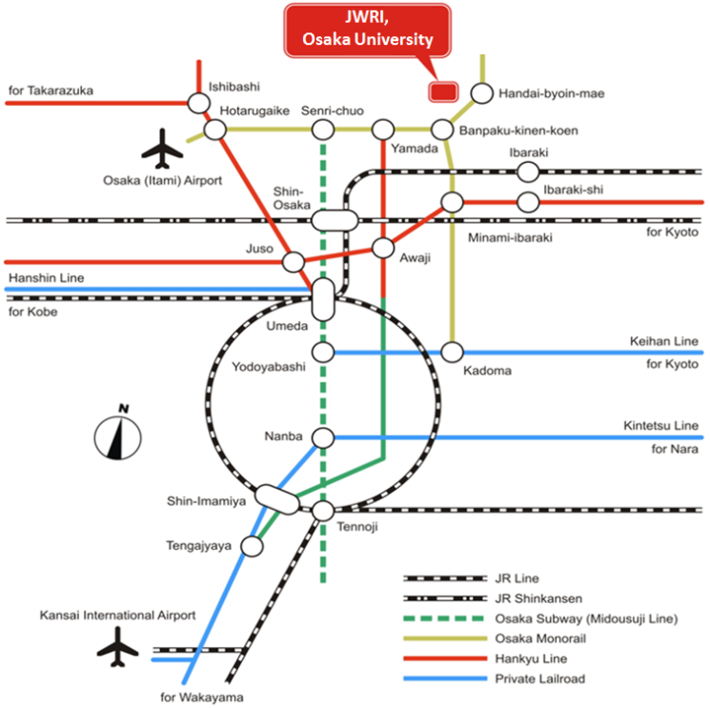
Location
The workshop will be held at JWRI, Osaka University
(http://www.jwri.osaka-u.ac.jp/en/).

Important Dates
March 31st Abstract due
April 30th Notification of final program

Schedule
May 23rd Registration, Lab-tour, Welcome party
May 24th Workshop (Arata Hall, JWRI)

Contacts
TAIWAN: Prof. C. Robert Kao
Email: crkao@ntu.edu.tw
JAPAN: Assoc. Prof. Hiroya Abe
Email: h-abe@jwri.osaka-u.ac.jp

